POSTER CONTENT

Background and Problem Definition

* Formula SAE is an intercollegiate engineering competition where teams design, build, and race open-wheel race cars. The Gryphon Racing team is currently downsizing to 10” rims to improve performance through decreases in CG, unsprung mass, and yaw inertia.
* A new carbon fiber rim design is the ideal solution to capitalize on these benefits because the unique material properties offer unmatched specific strengths and stiffnesses.

Objectives

* Develop a carbon rim design by performing materials research and appropriate structural analysis.
* Design and manufacture the required aluminum molds.
* Build a completed prototype rim through resin infusion layup and CNC machining.

Design Solution

* Words

\*PICTURE: FEA stuff\*

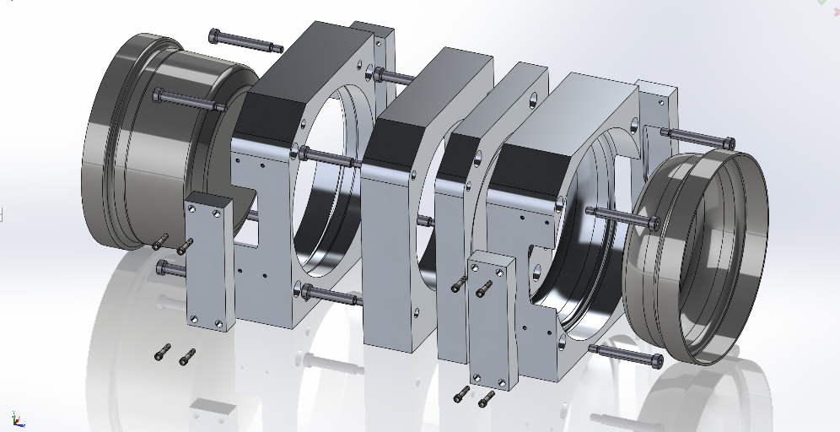

\*PICTURE: Templates for cutting carbon maybe, or something related to the layup?\*

Results

* A comprehensive carbon rim design process was carried out and documented for future use.
* A fully functional aluminum mold assembly was designed and manufactured.
* A prototype rim was built as a proof of concept.

\*PICTURE: Render of finished carbon rim with tire and wheel center mounted.\*